Project Prompt ECEN 5417

The power flow and short circuit data for the 14-bus IEEE benchmark system depicted below are presented in Tables 1 to 3. All generators and synchronous condensers are assumed to be connected in Δ, except for the one at Bus 8 which is assumed to be Y-grounded, since the data provided includes the step-up transformers in most machines. All loads are assumed to be Y-grounded, and are represented by the triangle symbol.

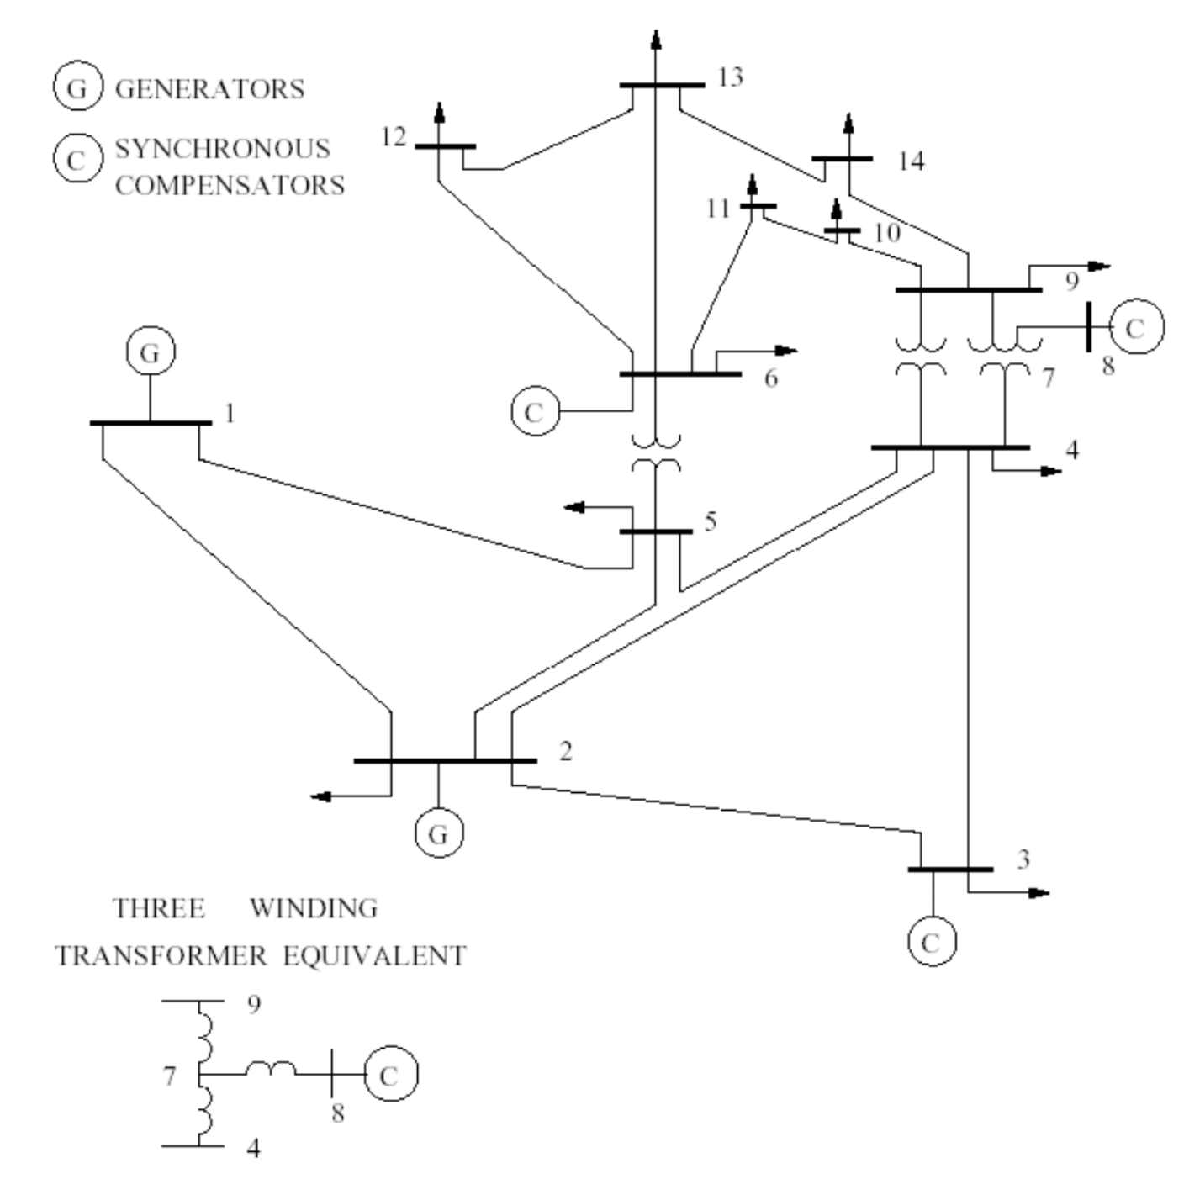

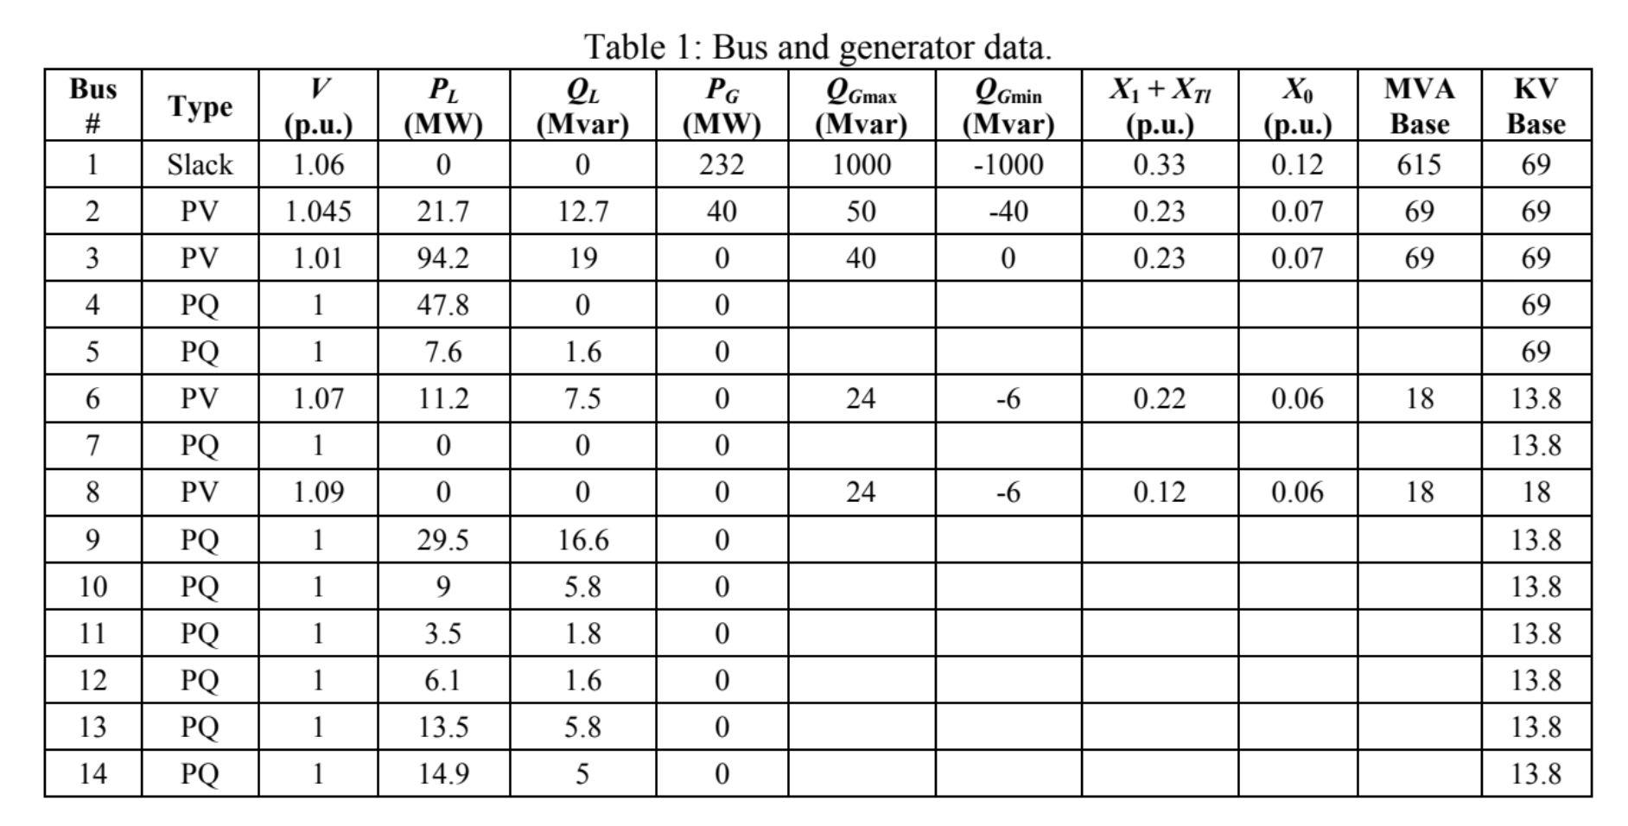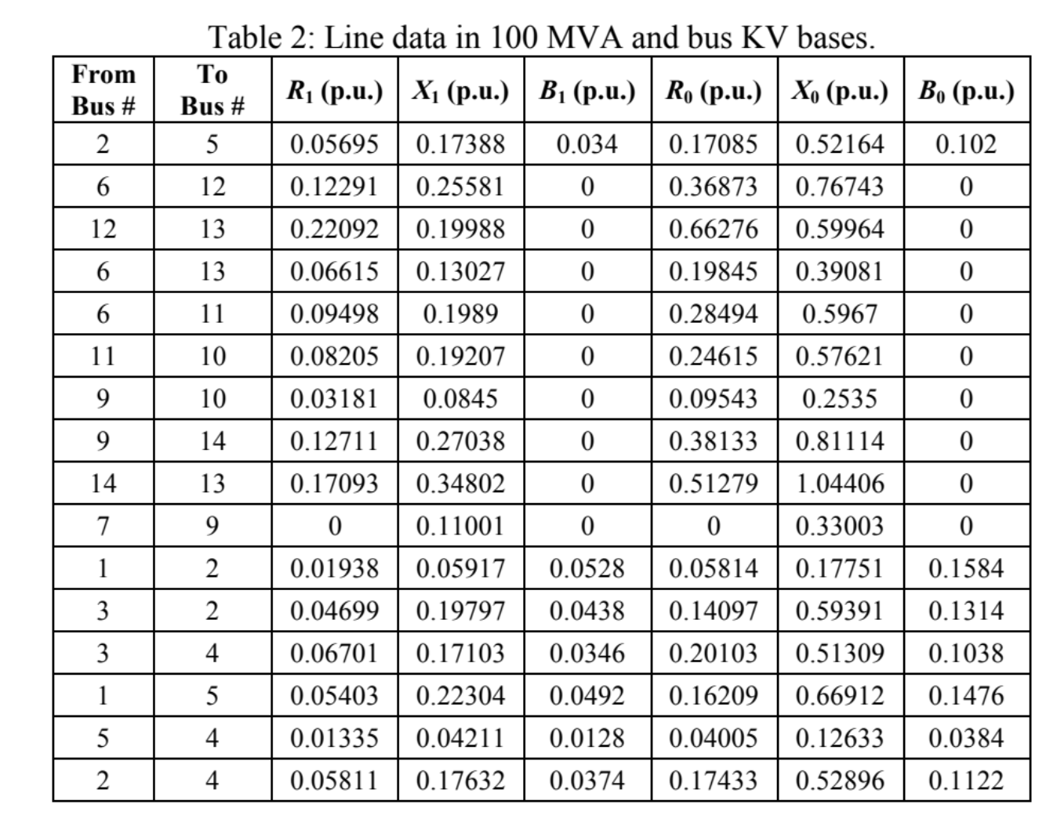

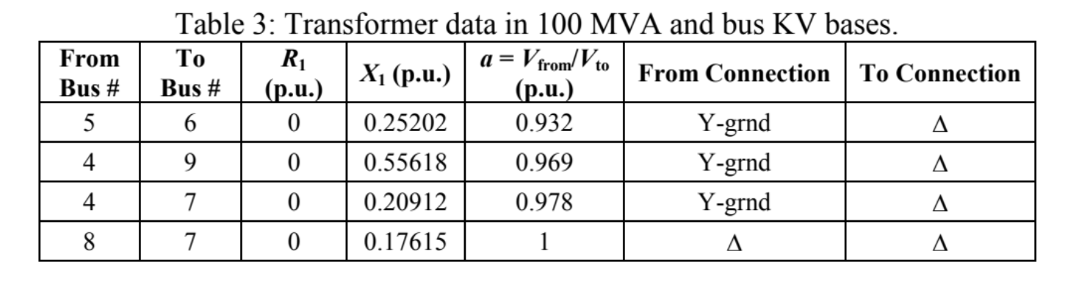

- PowerFlows (Employs PowerFlows.jl):
  - Determine the base power flow solution for the provided Sienna PowerSystems.jl data format file for 14 Buses enforcing the reactive power limits. E.g., passing the argument

ACPowerFlow(; check_reactive_power_limits = true)

  - Solve the same problem without enforcing the reactive power limits passing the argument:

ACPowerFlow(; check_reactive_power_limits = false)

Report on the observed differences in the system and explain why the results are different.
  - Increase the P and Q load at all buses by 40% and solve again enforcing reactive power limits. Report on what you have observed in the system voltages and the machine’s reactive power.

  - Determine the value of the shunt capacitor to be placed at Bus 14 that makes V14 approximately 1pu, with the loads at this 40% increased value. Report on the observed improvement on the system voltages.
  - Repeat the same analysis from point d. for Bus 13 (to yield V13 approximately 1 p.u.). State which placement is better, and why.

- Short Circuit (requires performing more manual work with the matrix operations in Julia):
  - Build the Ybus matrices for all negative and zero sequences based on the base power flow results from point 1.a. The positive sequence Ybus is provided from the code Ybus(system).The remaining matrices must be constructed using Julia.
  - For these power flow results and using matrix analysis, determine the phase fault currents in Amps and all node voltages in kV for 3-phase and 1-phase-to-ground solid faults at Bus 14. Which one is more severe and why?
  - Using matrix analysis, determine the phase fault currents in Amps for Lines 9-14 and 13-14 for the previously computed faults at Bus 14. Based on these results, what should be the size of the breakers to be placed at buses 9 and 13 for these two lines?

- Stability (Employs PowerFlows.jl):
  - Obtain the PV curve at Bus 14 by running a continuation power flow (CPF) using the base load and generation levels as the direction vector for the base system and for the system with Line 2-4 tripped, respectively.
  - Repeat the analysis from 3 a. adding the capacitor you recommended in Part 1.
  - Discuss the results and explain if the choice made in Part 1 is still appropriate.

Submissions requirements:
- The project must be turned in typed in computer and the figures rendered using plotting libraries.
- The project due date is not changeable. The project should be submitted December 15 by 11:59 pm.
- All Figures are expected to have proper axis labeling and titles.
- Non-legible results won’t be graded.
- All the code used must be submitted with a PDF rendering of the report. Non-reproducible code will cap the grade at 80%.

